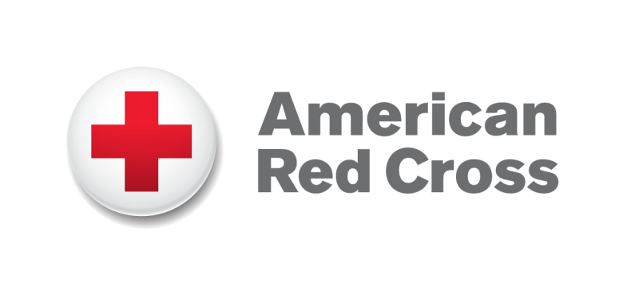

St. Louis Area Chapter  10195 Corporate Square  St. Louis, Missouri 63132  www.redcrossstl.org |  | Contact: Peggy Barnhart  Phone: (314) 516-2712  pbarnhart@redcrossstl.org

American Red Cross Responds to Tornadoes in Southern Illinois
Damage is heavy in Saline and Gallatin counties

St. Louis, Wednesday, March 1, 2012 – Following yesterday’s tornadoes in Southern Illinois, the American Red Cross Greater St. Louis Region has opened fixed meal sites at the Red Cross Shelter in First Baptist Church in Harrisburg, and in Ridgeway at Golden Circle Senior Center. Currently the Red Cross has 40 volunteers on the ground in Southern Illinois, with more ready to join the relief effort. The Red Cross has sent four disaster assessment teams to the region to determine the extent of the damage.

You can help people affected by disasters, like the Midwest tornadoes and storms, as well as countless crises at home and around the world, by making a donation to support American Red Cross disaster relief. Your gift enables the Red Cross to prepare for and provide shelter, food, emotional support and other assistance in disasters. To donate to disaster relief, visit www.redcross.org. For more information about local volunteer opportunities, emergency services, or a variety of other programs provided by the organization, please call 314.516.2800, in Southern Illinois call 618.529.1525, or log onto the St. Louis region website at www.redcrossstl.org.

About the American Red Cross St. Louis Area Chapter:
Founded in 1917, the American Red Cross St. Louis Area Chapter celebrates 93 years of dedicated service, providing emergency relief and preparedness training. The Red Cross is a charity, not a government agency, and depends on the efforts of thousands of volunteers and donors to provide a wide range of community support services, including disaster relief, first aid and CPR training, water safety, services to military personnel and support for blood services. The Chapter, a proud United Way agency, provides programs and services to St. Louis City, St. Louis County, St. Charles County and Jefferson County in Missouri, as well as Monroe, St. Clair (including Scott Air Force Base), Clay, Cumberland, Effingham, Fayette, Jasper and part of Madison County in Illinois. All disaster relief services are provided free of charge thanks to the generosity of the American people. To learn more about Red Cross programs, volunteer opportunities, and how you can help, contact the St. Louis Area Chapter at 314.516.2800 or www.redcrossstl.org.

About the American Red Cross:
The American Red Cross shelters, feeds and provides emotional support to victims of disasters; supplies nearly half of the nation's blood; teaches lifesaving skills; provides international humanitarian aid; and supports military members and their families. The Red Cross is a charitable organization — not a government agency — and depends on volunteers and the generosity of the American public to perform its mission. For more information, please visit www.redcross.org or join our blog at http://blog.redcross.org.

-##-

