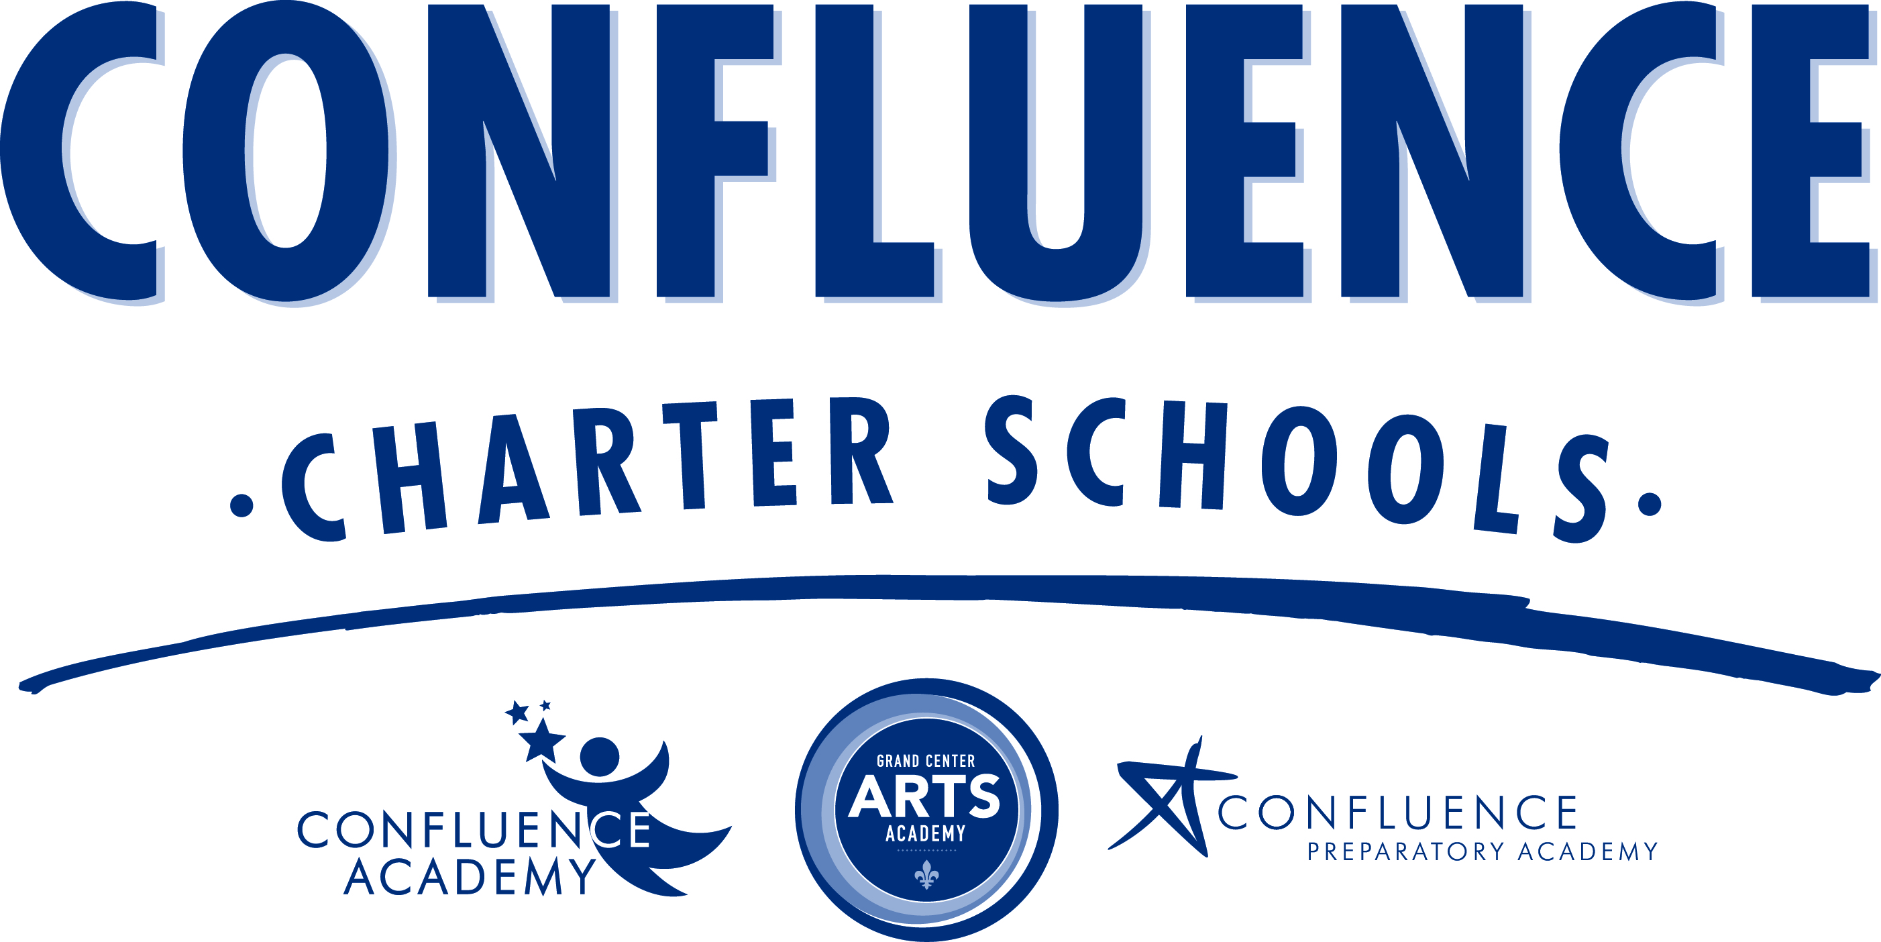

Media Statement – Confluence Charter Schools
Board of Directors announces leadership change at GCAA

May 31, 2013
Contact: Nez Savala, director of public relations, (314) 436-2313, (314) 387-3592
The Board of Directors of Confluence Charter Schools chose not to renew its contract with Lynne Glickert as principal of Grand Center Arts Academy. Philosophical differences led to the decision. It is a confidential personnel matter and we cannot discuss details. The Board recognizes Ms. Glickert for her contributions as the principal for the past three years. Largely through her efforts, the school has a solid foundation from which to build.

With respect to our primary goal of educating students and keeping their best interest in mind, the Board has selected Dr. Louise Losos as the new principal, effective July 1. She has 20 years of experience in education. Most recently, she was the principal at Clayton High School for seven years. For five years, she was an assistant principal at Parkway West High School and she taught social studies at Ladue Horton Watkins High School.

Dr. Losos has a bachelor’s degree in history from Harvard University and a master’s degree in history from Washington University in St. Louis. She has an education specialist degree and a Ph.D. in educational leadership from Saint Louis University. She is working toward a master’s of business administration from Webster University.

The Board is aware of the reason for Dr. Losos’ departure as principal of Clayton High School. We believe, based on her outstanding record as an educational leader, she deserves a second chance. We feel very fortunate she is joining our leadership team.

As we expand Grand Center Arts Academy into a full-fledged high school, it is of critical importance that we create and maintain a balanced program of academics and the arts. With that in mind, the Board has approved the search for an arts integration coordinator to work alongside Dr. Losos as we continue to grow.

The Board has high expectations for Grand Center Arts Academy. As principal, Dr. Losos will engage parents and community partners to expand the great team at GCAA. She is looking forward to working with our students, families, teachers and staff. Becoming the principal of Grand Center Arts Academy is an opportunity for her to “do something new and exciting in education and to define the future” for our school.

Key Facts about Grand Center Arts Academy

- Grand Center Arts Academy is the first performing and visual arts charter school in Missouri.
- Classes include core curriculum of math, science, communication arts and social studies, along with dance, music, art and theater.
- GCAA opened in 2010-2011 with students in grades 6-7; classes were held at Third Baptist Church in the Grand Center community.
- GCAA welcomed its first class of ninth-grade students in 2012-2013. Grades will be added each year through 12th grade in 2015-2016.
- Fifteen (15) percent of students attend GCAA through the region’s voluntary student transfer program.
- Enrollment in 2012-2013 was 433.
- GCAA is a Confluence Charter School sponsored by Saint Louis University.
- In January 2014, GCAA will expand into renovated space at the Sun Theatre. The expansion includes almost 30,000 square feet and will allow GCAA to accommodate another 100-125 students.
- The expansion will set GCAA apart as the only public charter school in St. Louis to specialize in the arts with a 650-seat theater.
- The renovation project is a partnership with The Lawrence Group, an architecture firm, and Grand Center, Inc., a non-profit dedicated to the growth and development of the historic arts and cultural district. The estimated cost is $11.4 million.
- Confluence Charter Schools will rent the space.

-30-

