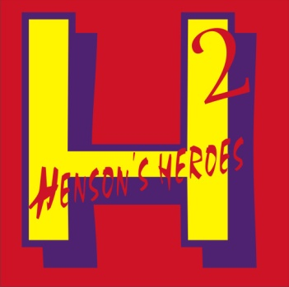 Henson’s Heroes 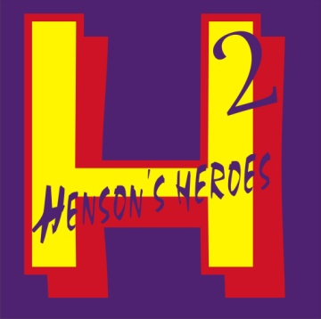
Raegan was diagnosed with a brain tumor Dec 4, 2011. While hospitalized at Children’s Mercy Hospital (CMH) in Kansas City, she received a blanket from another little girl who had been a patient. Raegan’s first response was to figure out a way that she could do something as thoughtful when she was all better. At a time when that thought was very hard to bear, not knowing what their future would hold, her family planned with Raegan for weeks coming up with ideas to do just that. While in the hospital, her family saw a little boy. Full of life, vivacious, and strong, playing with the nurses and running the halls with his IV and external shunt poles. Caleb was brought into their life. The nurses shared the story of a boy, who would later be identified as the boy racing through the halls with his IV and shunt poles, and his hunger for life. Caleb was born with a brain malformation and cerebral spinal fluid issues. The nurses and doctors encouraged Raegan’s family through Caleb and his story and explained that he lived with a shunt and had a full life doing everything he loved. Snowboarding, baseball, football, basketball, and anything else that involved simply living life to the fullest in spite of enduring numerous surgeries, shunts, and literally growing up in the hospital. Raegan’s stay at Children’s Mercy was relatively short compared to that of Caleb’s given his approximately 100 surgeries and 40 shunts. However, both families were (and are) forever changed by their stays at Children’s Mercy Hospital in Kansas City, MO. Being brought together by another “Brain Buddy,” Caleb and Raegan’s moms managed to make contact. 1 year after their chance encounter at CMH, they began Henson’s Heroes. The two families have dedicated their time and hearts to making life more bearable for patients, and their families, who are living their own stories out at Children’s Mercy, as well as the staff who are there to do the same. The nursing staff, doctors, Child Life specialists, therapists, nursing assistants, and medical technicians at CMH are the true HEROES. But with the help of other families and friends it is our hope to become their Heroes and give back to all who are, and will be, part of their own Children’s Mercy story.
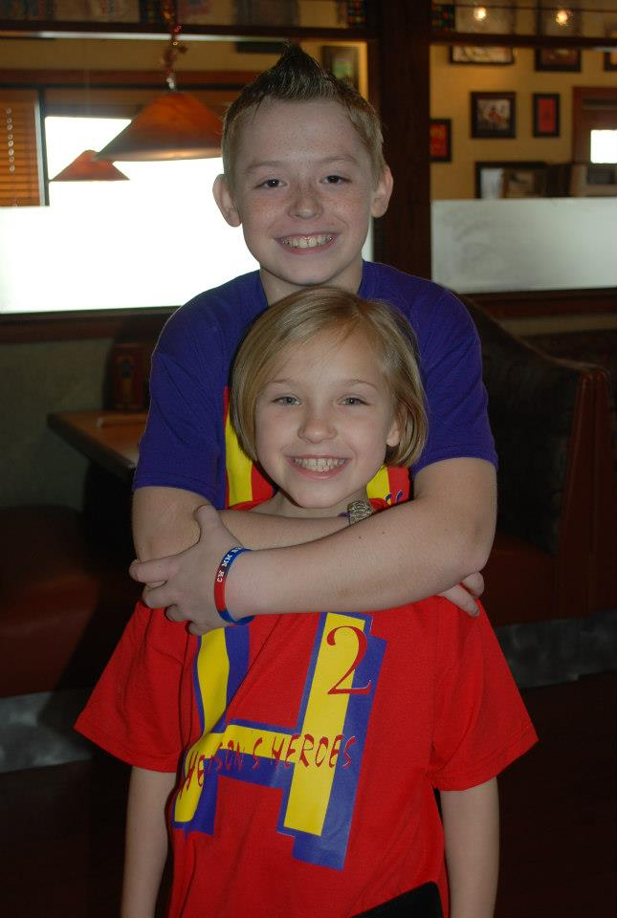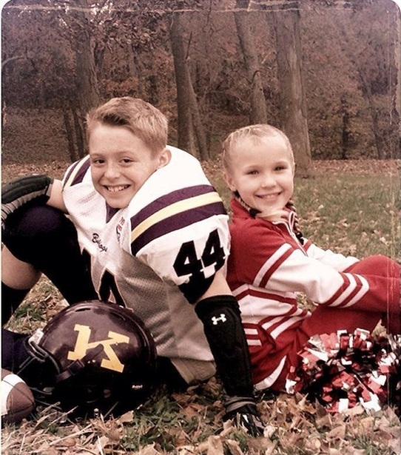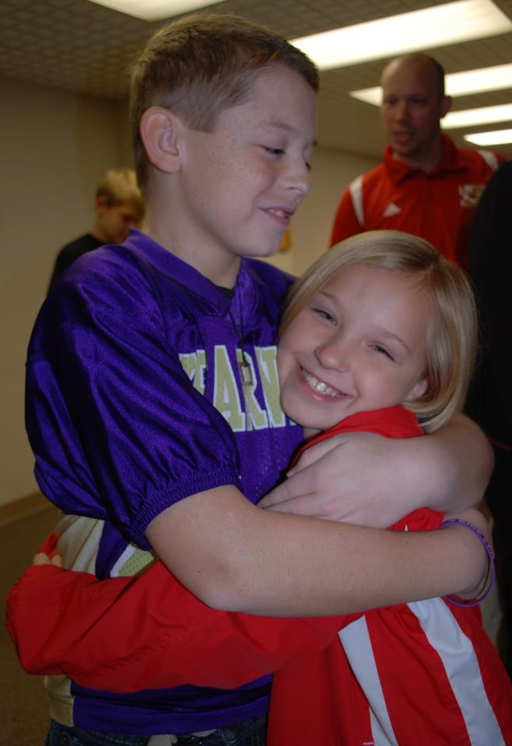

Mission Statement
“Be the change you wish to see in the world.”
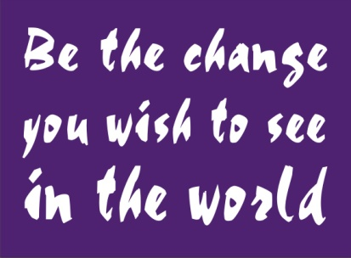

Purpose
The purpose for Henson’s Heroes is to provide items of need, comfort, and enjoyment for Children’s Mercy’s 2 Henson patients, family members, Child Life, and nurses/staff.

Goal
Our goal is to provide items of need, comfort, and enjoyment to the patients and families of these patients during their time of need, as well as 2 Henson staff.

Going Forward
Going forward we leave open the idea of changing our goals and purposes to fit the needs of these same people. Whether it be monetary support or items of need we will provide this at no cost to the Hospital or the Families.

Facebook Page
We can be found at Henson’s Heroes on Facebook.
