Major Case Squad of Greater St. Louis
Press Release
Contact: Detective Shawn Reiland 314-737-1282 (Cell)
sreiland@florissantmo.com

For Immediate Release: May 6, 2015
WARRANTS ISSUED IN TAYLOR CLARK HOMICIDE
Hazelwood, MO-Warrants were issued Wednesday, May 6, 2015 for Michael Gordon by the St. Louis County Prosecuting Attorney’s Office for Murder in the First Degree and Armed Criminal Action.
On Tuesday, May 5, 2015 at approximately 5:15pm officers with the Hazelwood Police Department discovered the remains of Taylor Clark after locating his vehicle a short distance away. The Major Case Squad of Greater St. Louis was called upon to assist in the investigation.
An investigation by Major Case Squad Investigators revealed that Clark posted his vehicle for sale on CraigsList. Gordon contacted Clark about the vehicle, and arrangements were made for Gordon to test drive the vehicle, at Gordon’s place of employment, MTC Truck Driver Training, in the 12000 blk of Missouri Bottom Road. After the initial meeting, Gordon shot Clark one time, causing his death. Gordon then moved Clark’s body to the wooded area a short distance behind the meeting location. Gordon was arrested without incident.
Michael Gordon is identified as:
Michael Gordon
DOB: 07/01/1990
6600 blk Minnesota
St. Louis, MO 63019
Gordon will be transferred to the St. Louis County Jail, where he will be held on a $1,000,000.00 bond.
The investigation into Clark’s death is continuing, and the Major Case Squad is asking for the public’s assistance in locating a:
Red 1990 BMW 325i
Missouri License Plate FL3Z9K

(Exemplar Photo)
Anyone who has information on the whereabouts of the above vehicle is encouraged to call the Hazelwood Police Department at 314-513-5225.

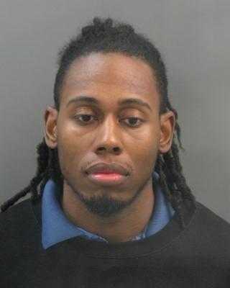
Michael Gordon
DOB: 07/01/1990

