

**The Office of the Superintendent**

160 S. Hollywood Street • Memphis, TN 38112 • (901) 416-5444 • Fax (901) 416-5578 • www.scsk12.org

**Dorsey E. Hopson, II Esq.**

Superintendent

April 9, 2015

Parents and Guardians,

You may have heard recently in your community and in the local media about attempts to convert Hamilton High School to charter school in 2015-16. I wanted to personally reach out and inform you that this is NOT true.

Principal Curtis Weathers had intended to apply for a conversion of Hamilton next year, but has informed us that he will no longer be pursuing such a change. Hamilton High School has long been one of our flagship schools, and it will remain a part of Shelby County Schools and our highly successful iZone program next year.

We have already started the process of finding another highly qualified candidate to lead Hamilton High School in 2015-16 and beyond. As an iZone school, there is a very rigorous process we must go through to ensure we select a principal who can meet our high expectations for this school and community.

Principal Weathers will remain at Hamilton throughout the end of this school year, and he is committed to working hard to finish this year on a positive note.

I know this situation has caused some concern, so I wanted to make sure you had accurate information of our plans for Hamilton High. Your continued support will be vital to the success of our students, and we are thankful for you partnership.

Sincerely,

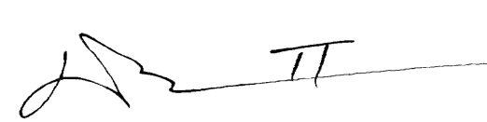

Dorsey E. Hopson, II Esq.

Superintendent